Applying Styles Directly to HTML Elements
Using the style Attribute:
To apply styles directly to an HTML element, you use the style attribute. This attribute takes a CSS declaration as its value. A CSS declaration consists of a property and a value, separated by a colon. For example:
<p style="color: red; font-size: 20px;">This text is red and 20px in size.</p>
In this example, the color property is set to "red" and the font-size property is set to "20px"
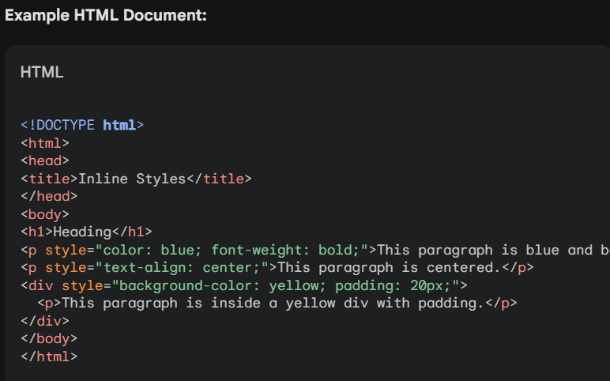

Pros of Inline Styles:
- Simple and straightforward: Inline styles are easy to use and understand.
- Immediate effect: Changes made to inline styles are immediately visible in the browser.
Cons of Inline Styles:
- Poor readability: Inline styles can make HTML code harder to read and maintain, especially for complex styles.
- Lack of reusability: Styles defined inline cannot be reused for multiple elements.
- Maintenance issues: Updating styles requires modifying the HTML code, which can be error-prone.
When to Use Inline Styles:
- Quick and simple styling: For minor style adjustments or temporary styles, inline styles can be convenient.
- One-off styles: If a style is only needed for a single element and won't be reused, inline styles can be appropriate.

